Home Page:
- Missing “Why Smart Fleet” page as per Handoff Document - Phase 1 Deliverable. This was a suppose to be a “rename” from “Full Fact.”.
- Missing Landing Page:
- Remove “Home” tab from top header, as the logo will always be the “home” button.
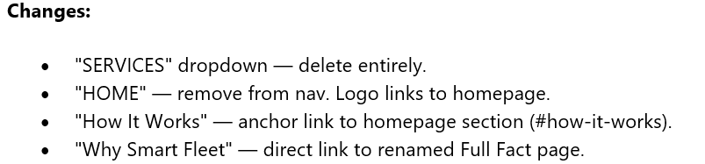
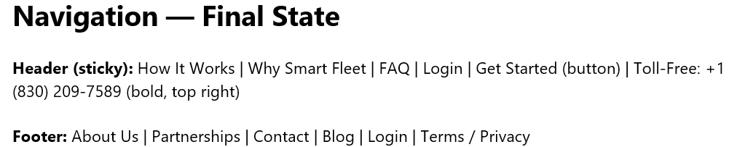
- Remove “Curious to Learn More” button as per Handoff document

- Remove “Why Choose Us” section as per Handoff Document.
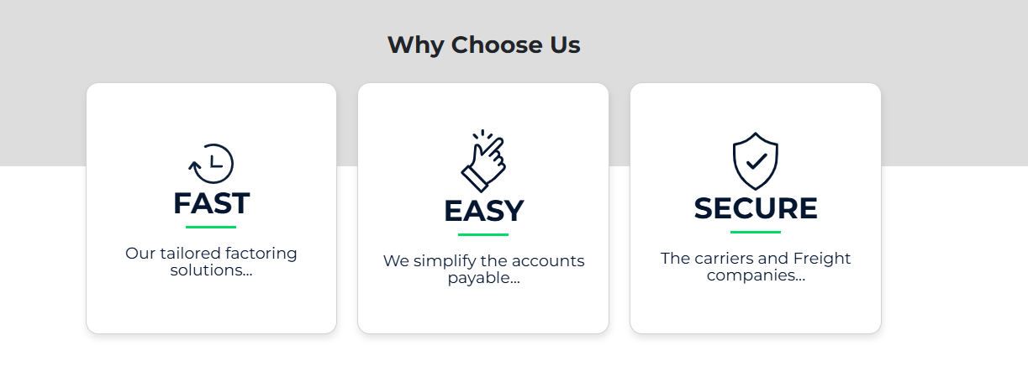
- Remove “Interested in learning MORE? Give us a call today.” and “Let’s talk” button
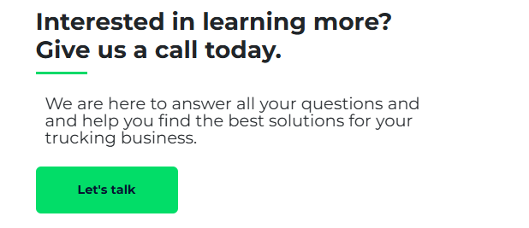

- Remove Video and text to the left of video frame.


Handoff Documents – Page 8 of 27:
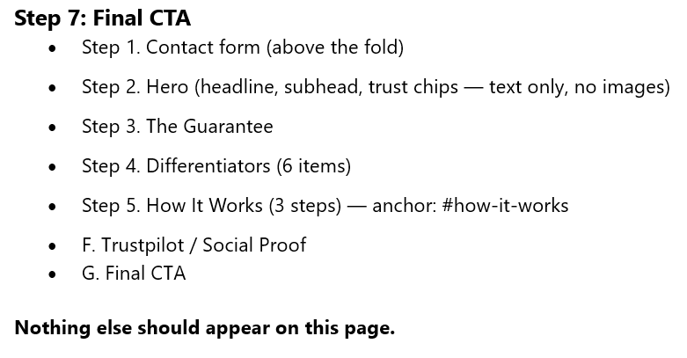

- Two “banners” at the bottom of the home page with white space between them? Please clean that up.
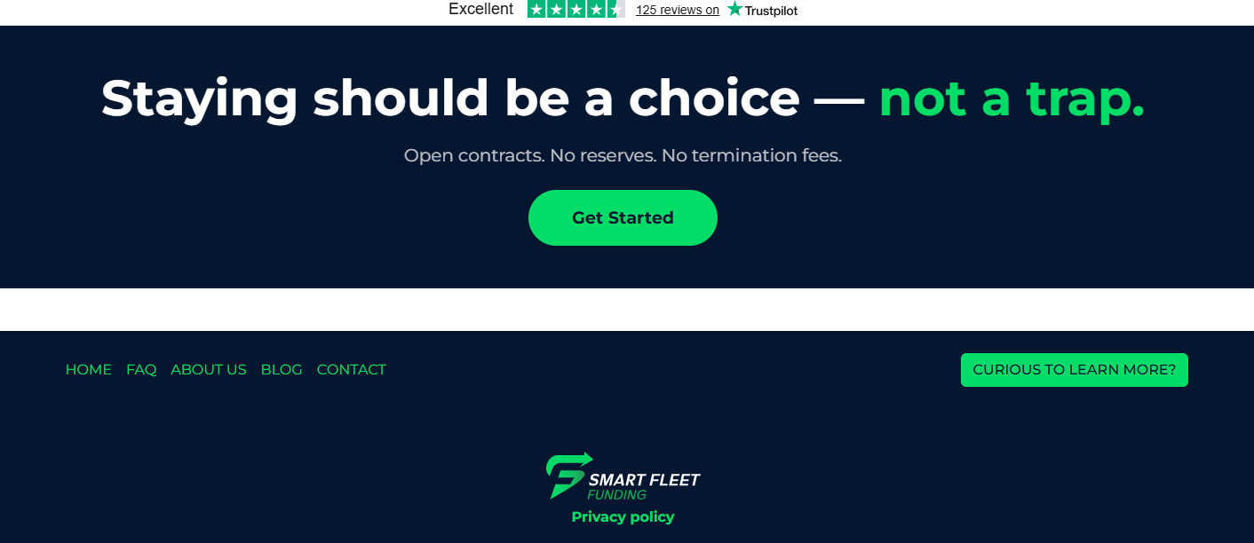

- Please make font for phone number bigger
- Please make “Get Started” button bigger to match bigger font for phone number.

